### 

### Semester One Examination, 2019

### Question/Answer booklet

# Yr 12 SPECIALIST

**UNIT 3**

## Section Two:

## Calculator-assumed

|  |
| --- |
|  |

Your Name

Your Teacher’s Name

## Time allowed for this section

Reading time before commencing work: ten minutes

Working time: one hundred minutes

## Materials required/recommended for this section

***To be provided by the supervisor***

This Question/Answer booklet

Formula sheet (retained from Section One)

***To be provided by the candidate***

Standard items: pens (blue/black preferred), pencils (including coloured), sharpener, correction fluid/tape, eraser, ruler, highlighters

Special items: drawing instruments, templates, notes on two unfolded sheets of A4 paper, and up to three calculators approved for use in this examination

## Important note to candidates

No other items may be taken into the examination room. It is **your** responsibility to ensure that you do not have any unauthorised material. If you have any unauthorised material with you, hand it to the supervisor **before** reading any further.

|  |  |  |  |  |  |
| --- | --- | --- | --- | --- | --- |
| **Question** | **Marks** | **Max** | **Question** | **Marks** | **Max** |
| **8** |  | **6** | **15** |  | **8** |
| **9** |  | **6** | **16** |  | **4** |
| **10** |  | **8** | **17** |  | **4** |
| **11** |  | **5** | **18** |  | **9** |
| **12** |  | **5** | **19** |  | **13** |
| **13** |  | **6** | **20** |  | **9** |
| **14** |  | **10** |  |

**Structure of this paper**

|  |  |  |  |  |  |
| --- | --- | --- | --- | --- | --- |
| Section | Number of questions available | Number of questions to be answered | Working time (minutes) | Marks available | Percentage of examination |
| Section One:  Calculator-free | 7 | 7 | 50 | 49 | 34.5 |
| Section Two:  Calculator-assumed | 13 | 13 | 100 | 93 | 65.5 |
|  |  |  |  | **Total** | 100 |

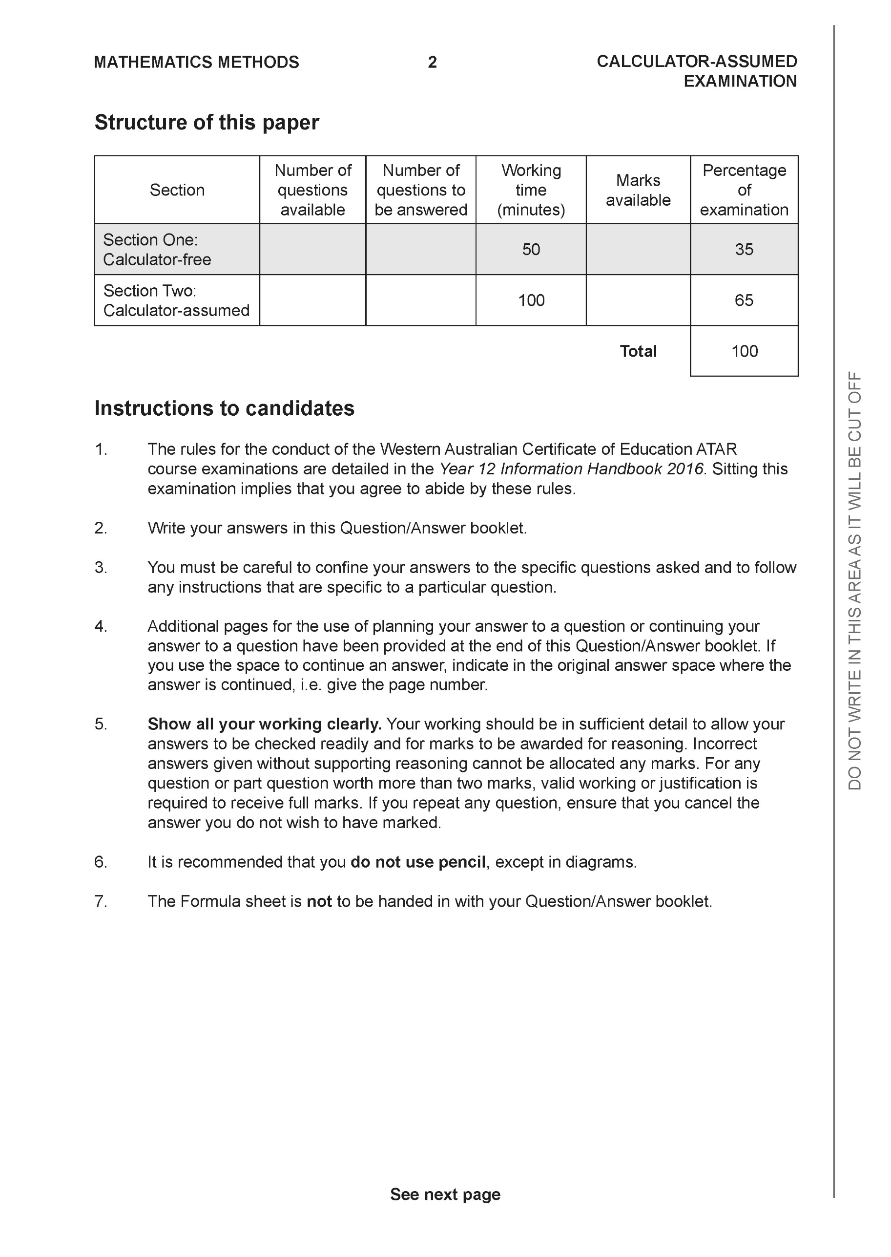

**Section Two: Calculator-assumed (93 Marks)**

This section has **13** questions. Answer **all** questions. Write your answers in the spaces provided.

Spare pages are included at the end of this booklet. They can be used for planning your responses and/or as additional space if required to continue an answer.

● Planning: If you use the spare pages for planning, indicate this clearly at the top of the page.

● Continuing an answer: If you need to use the space to continue an answer, indicate in the original answer space where the answer is continued, i.e. give the page number. Fill in the number of the question that you are continuing to answer at the top of the page.

Working time: 100 minutes.

**Question 8 (6 marks)**

1. Sketch the following region in the complex plane,  (3 marks)

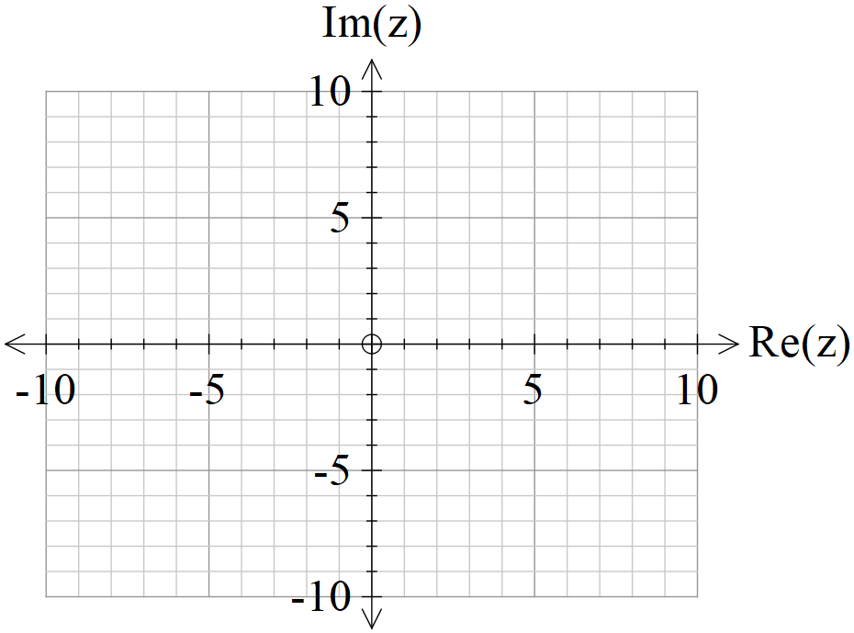

1. Determine the cartesian equation of  (3 marks)

**Question 9 (6 marks)**

1. Given that , where  is a constant, is only true for , determine the value of .

(3 marks)

1. Given that , where  are constants, is only true for  , determine the values of . (3 marks)

**Question 10 (8 marks)**

Consider the locus of points on  in the complex plane.

1. Sketch this locus below. (2 marks)

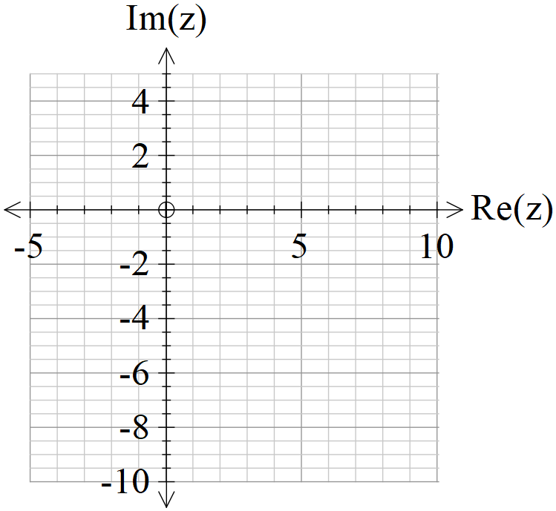

1. Determine the minimum principal on this locus to one decimal place.

(3 marks)

1. Determine the maximum value of  on this locus. (3 marks)

**Question 11 (5 marks)**

Show that the line  is parallel to the plane  and determine its distance from the plane.

**Question 12 (5 marks)**

Let , where , consider the sum .

1. Sketch a diagram of this sum in the complex plane. (2 marks)
2. Obtain an expression for the  in terms of . (3 marks)

**Question 13 (6 marks)**

1. Determine a vector that is perpendicular to both and  and has a magnitude of .(Do not simplify) (3 marks)
2. Let  and  where  is a real constant. In terms of , determine an expression for the angle between . (3 marks)

**Question 14 (10 marks)**

Consider a plane defined by .

1. Determine a normal vector to this plane. (1 mark)
2. Determine the cartesian equation of this plane. (2 marks)
3. Show how to determine the distance of point  from the plane above **using** scalar dot product and the normal vector. (4 marks)
4. Consider a general plane , where  are constants. Show that the distance of point  from this plane is given by the expression  (3 marks)

**Question 15 (8 marks)**

In deep space an astronaut is space walking outside a stationary space station. At time  seconds the astronaut is positioned at  metres relative to the space station and is moving with a velocity of  metres per second. A rogue satellite is observed to be at position at time  with a velocity of metres per second relative to the space station.

The satellite emits radiation and if the astronaut comes within 70 metres of the satellite the dosage will be harmful.

1. Determine the distance between the astronaut and satellite at  seconds.

(3 marks)

1. Determine if the astronaut is in danger and if so for how long in seconds to two decimal places. (Justify your answer).

(5 marks)

**Question 16 (4 marks)**

Consider the two spheres  and .

Determine whether there are any common points on both spheres. Justify your answer.

**Question 17 (4 marks)**

Show **using vector cross** **product**, how to determine the distance of point  from the line  .

**Question 18 (9 marks)**

Consider the line  and the sphere  where  is a constant.

Determine the values of , to two decimal places, for each of the following scenarios:

(Justify your answers)

1. the line does not meet the sphere at all.
2. the line meets the sphere at two points.
3. the line is a tangent to the sphere.

**Question 19 (13 marks)**

Consider a prism where opposite sides are congruent parallelograms(parallelepiped) with coordinates .

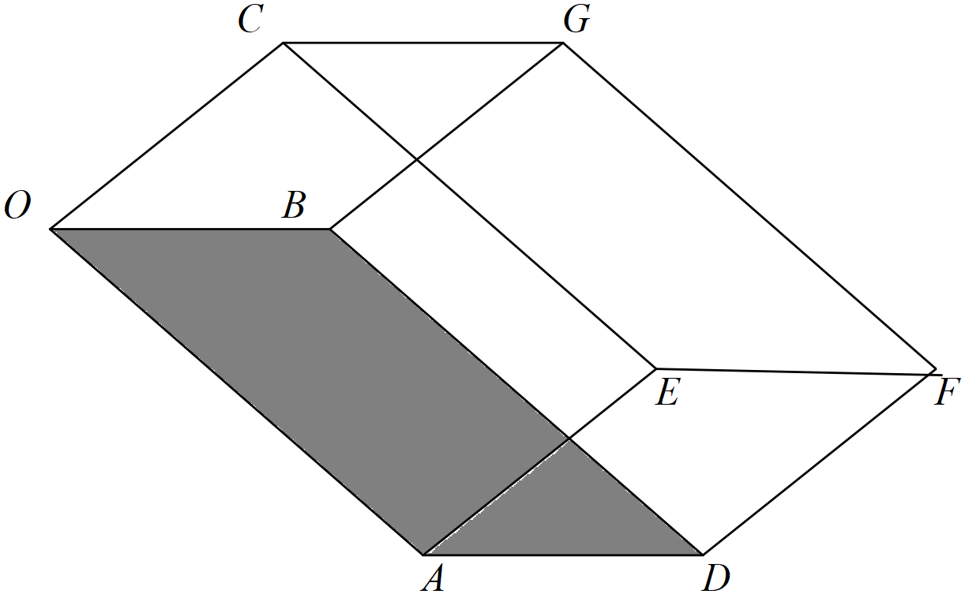

1. Determine a unit normal vector to the base . (3 marks)
2. Using this unit normal, determine the distance between the faces .

(Hint-use vector ) (3 marks)

1. Show using cross product how to determine the area of the base .

(2 marks)

1. Hence or otherwise, determine the volume of the prism. (3 marks)
2. In terms of the vectors  write an expression using cross and dot products to represent the volume of the prism. (2 marks)

**Question 20 (9 marks)**

Consider a single photon of light that is released from a box positioned at point A and moves in a direction of  hitting a planar sheet of glass at point B. The planar sheet of glass is given by . The photon is refracted, that is changes direction, through the glass such that the angle with the perpendicular is  and passes through point D.

It is given that the vectors  and the normal are all in the same plane.

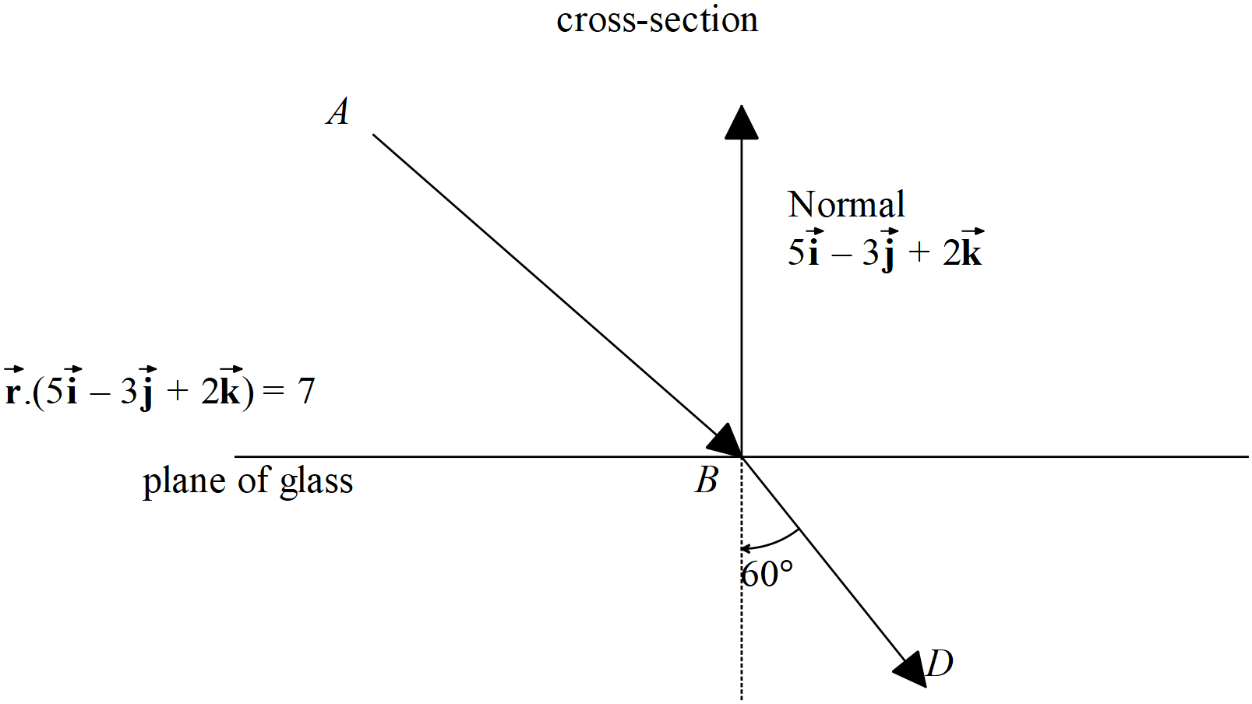

1. Determine the point . (3 marks)

Assume that  is a unit vector and be represented as  with 

1. Determine two other independent equations for . (4 marks)

Question continued

1. Hence solve for vector  using your CAS calculator (simultaneous) to 2 decimal places.

(2 marks)

Additional working space

Question number:

Additional working space

Question number: